=============================================

=========== Bug Report Template 1 ==============

=============================================

**Bug ID:** 001

**Tester:** Alexandra

**Date (submitted):** 11.09.2022

**Title: Number of products can’t be changed in the shopping cart**

**==== Bug Description ====**

**URL: https://www.saucedemo.com/**

**Summary:** When the client add some products in the shopping cart and move forward with the next step and realizing that he want more products of the same sort but he can’t add more than 1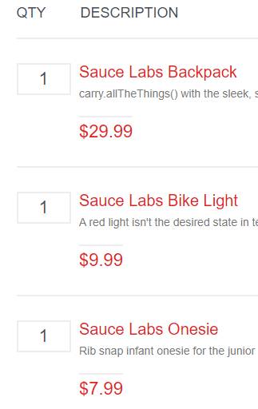

**Screenshot:**

**Platform:**

**Browser:** Google Chrome

**==== Administrative ====**

**Assigned To:** Alin

**Date (assigned):** 11.09.2022

**Priority:** High priority

**Severity:** High severity

**==== Additional Notes ====**

**Steps to Reproduce:**

1) Navigate to https://www.saucedemo.com/

2) Introduce username and password

3) Click submit

4) Go to product list

5) Add products in the cart

6) Add more than 1 item for the same product

**Expected results:**

Website should be open and user have to be able to enter the credentials, customer is logged in and the shopping list should be open. It should let to add how many products do you want and let you to to add more than 1 item for the same product.

**Actual results:**

To the shopping list, the client can’t add more than 1 for the same product

=============================================

=========== Bug Report Template 2 ==============

=============================================

**Bug ID:** 002

**Tester:** Alexandra

**Date (submitted):** Alin

**Title: Log in unsuccessfully**

**==== Bug Description ====**

**URL: https://www.saucedemo.com/**

**Summary: When the credentials are entered an error message appear “sorry, this user has been locked out”**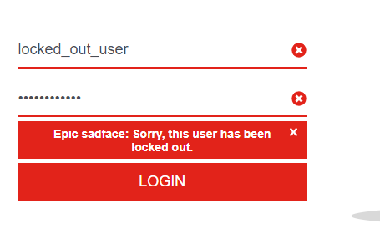

**Screenshot:**

**Platform:**

**Browser:** Google Chrome

**==== Administrative ====**

**Assigned To:** Alin

**Date (assigned):** 11.09.2022

**Priority:** High

**Severity:** High

**==== Additional Notes ====**

**Steps to Reproduce:**

1) Open the Website

2) Enter credentials

3) Click Submit

**Expected results:**

When the credentials are introduce, site should log in successfully.

**Actual results:**

After the credentials are introduce an error message appear **“**sorry, this user has been locked out**”**

=============================================

=========== Bug Report Template 3 ==============

=============================================

**Bug ID:** 003

**Tester:** Alexandra

**Date (submitted):** 11.09.2022

**Title: Same picture at all of the products**

**==== Bug Description ====**

**URL: https://www.saucedemo.com/**

**Summary:** When the client open the products list, he see same picture on all of the products

**Screenshot:** 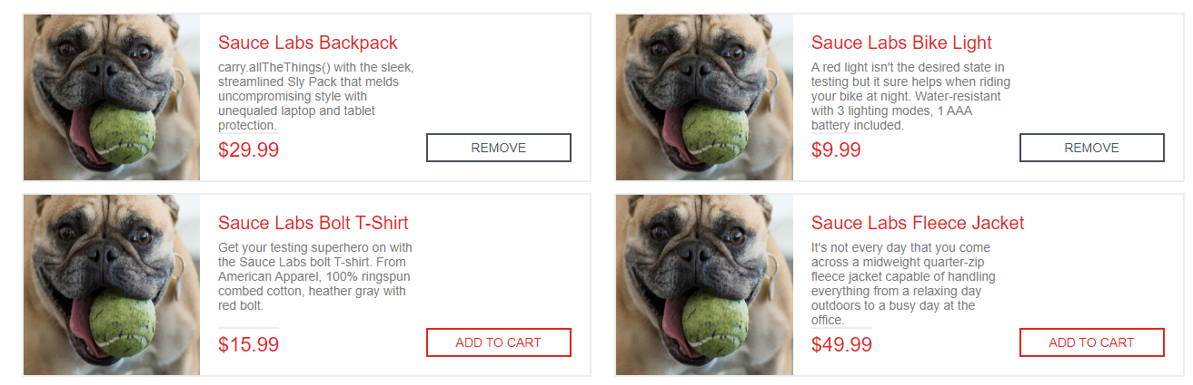

**Platform:**

**Browser:** Google Chrome

**==== Administrative ====**

**Assigned To:** Alin

**Date (assigned):** 11.09.2022

**Priority:** High

**Severity:** Low

**==== Additional Notes ====**

**Steps to Reproduce:**

1) Open the Website

2) Enter credentials

3) Click Submit

4) Go to a products list

5) The products are described

**Expected results:**

Site should be visible, the user is able to type the credentials, clicking submit redirect the user to the ecommerce page. List should be visible with all of the products and each product should have a image which representing the product, a description and a price

**Actual results:**

All of the products has a same image which doesn't have a connection with product list, but the real image appear when click on the product to see all the informations about that item.

=============================================

=========== Bug Report Template 4 ==============

=============================================

**Bug ID:** 004

**Tester:** Alexandra

**Date (submitted):** 11.09.2022

**Title: Not all the products can be added at the shopping list**

**==== Bug Description ====**

**URL: https://www.saucedemo.com/**

**Summary:** At the products list, some of them can’t be added at shopping lis**t**

**Screenshot:** screen recording

**Platform:**

**Browser:** Google Chrome

**==== Administrative ====**

**Assigned To:** Alin

**Date (assigned):** 11.09.2022

**Priority:** High

**Severity:** High

**==== Additional Notes ====**

**Steps to Reproduce:**

1) Open the Website

2)Enter credentials

3) Click submit

4) Go to a products list

5) Add products in the shopping cart

**Expected results:**

1) saucedemo.com should be visible on the screen

2) User is able to type the credentials

3) clicking submit redirect the user to the ecommerce page

4) List should be visible with all of the products

5) It should let you add as many products as you want

**Actual results:**

When the client want to add some product in the shopping list, some of them will not be able to be added.